**TESTING METHODOLOGIES CC1**

**BALA SUBRAMANI V S**

**727721euai012**

**QN:1-**

**Code:**

**package** com.example.thursday.selproj2;

**import** org.openqa.selenium.By;

**import** org.openqa.selenium.WebDriver;

**import** org.openqa.selenium.edge.EdgeDriver;

**import** io.github.bonigarcia.wdm.WebDriverManager;

**public** **class** test1 {

**public** **static** **void** main(String[] args) {

// **TODO** Auto-generated method stub

WebDriverManager.*edgedriver*().setup();

WebDriver driver = **new** EdgeDriver();

driver.get("https://www.saucedemo.com/");

driver.manage().window().maximize();

driver.findElement(By.*id*("user-name")).sendKeys("standard_user");

driver.findElement(By.*id*("password")).sendKeys("secret_sauce");

driver.findElement(By.*id*("login-button")).click();

driver.findElement(By.*xpath*("//*[@id=\"add-to-cart-sauce-labs-backpack\"]")).click();

String cartCount = driver.findElement(By.*xpath*("/html/body/div/div/div/div[1]/div[1]/div[3]/a/span")).getText();

driver.findElement(By.*xpath*("/html/body/div/div/div/div[1]/div[1]/div[3]/a")).click();

String product = "Sauce Labs Backpack";

driver.findElement(By.*xpath*("//*[@id=\"checkout\"]")).click();

driver.findElement(By.*xpath*("//*[@id=\"first-name\"]")).sendKeys("");

driver.findElement(By.*xpath*("//*[@id=\"last-name\"]")).sendKeys("");

driver.findElement(By.*xpath*("//*[@id=\"postal-code\"]")).sendKeys("");

driver.findElement(By.*xpath*("//*[@id=\"continue\"]")).click();

System.***out***.println("Name of the product: " + driver.findElement(By.*xpath*("/html/body/div/div/div/div[2]/div/div[1]/div[3]/div[2]/a/div")).getText());

System.***out***.println("Price of the product: " + driver.findElement(By.*xpath*("/html/body/div/div/div/div[2]/div/div[1]/div[3]/div[2]/div[2]/div")).getText());

}

}

**Output:**

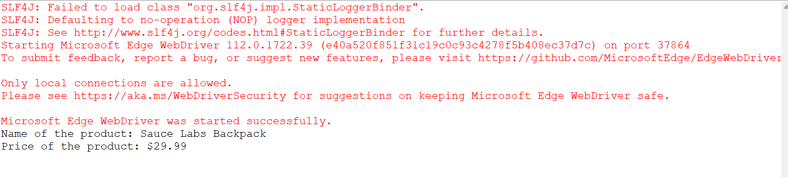

**QN:2-**

**Code:**

**package** com.example.thursday.selproj2;

**import** org.openqa.selenium.By;

**import** org.openqa.selenium.WebDriver;

**import** org.openqa.selenium.edge.EdgeDriver;

**import** io.github.bonigarcia.wdm.WebDriverManager;

**public** **class** test2 {

**public** **static** **void** main(String[] args) **throws** InterruptedException {

WebDriverManager.*edgedriver*().setup();

WebDriver driver = **new** EdgeDriver();

driver.get ("https://www.saucedemo.com/");

driver.manage().window().maximize() ;

driver.findElement(By.*xpath*("//*[@id=\"user-name\"]")).sendKeys("standard_user");

driver.findElement(By.*xpath*("//*[@id=\"password\"]")).sendKeys("secret_sauce");

driver.findElement(By.*xpath*("//*[@id=\"login-button\"]")).click();

String firsttext=driver.findElement(By.*xpath*("//*[@id=\"item_4_title_link\"]/div")).getText();

System.***out***.println(firsttext);

driver.findElement(By.*xpath*("//*[@id=\"header_container\"]/div[2]/div/span/select")).click();

driver.findElement(By.*xpath*("//*[@id=\"header_container\"]/div[2]/div/span/select/option[2]")).click();

String secondtext=driver.findElement(By.*xpath*("//*[@id=\"item_3_title_link\"]/div")).getText();

System.***out***.println(secondtext);

System.***out***.println("Filter (A-Z and Z-A) applied successfully");

driver.findElement(By.*xpath*("//*[@id=\"header_container\"]/div[2]/div/span/select")).click();

driver.findElement(By.*xpath*("//*[@id=\"header_container\"]/div[2]/div/span/select/option[3]")).click();

String thirdtext=driver.findElement(By.*xpath*("//*[@id=\"inventory_container\"]/div/div[1]/div[2]/div[2]/div")).getText();

System.***out***.println(thirdtext);

driver.findElement(By.*xpath*("//*[@id=\"header_container\"]/div[2]/div/span/select")).click();

driver.findElement(By.*xpath*("//*[@id=\"header_container\"]/div[2]/div/span/select/option[4]")).click();

String fourthtext=driver.findElement(By.*xpath*("//*[@id=\"inventory_container\"]/div/div[1]/div[2]/div[2]/div")).getText();

System.***out***.println(fourthtext);

System.***out***.println("filter (low price- high price and high price - low price ) applied sucessfully");

Thread.*sleep*(5000);

driver.quit();

}

}

**Output:**

